**RMON LINK UTIL**

History

|  |  |  |  |
| --- | --- | --- | --- |
| Date | Details | Proposal | comment |
| 20/05/20 | Included logic to trace down the internal layer connection. And able to extract the Realtime Statistics based on the provided requirement. (used postman) | Based on the inputs from Thorsten, have to include Air Interface capacity Calculation. |  |
| 30/05/20 | Included Air interface capacity calculation and ported the code from java script to java for demo purpose. |  |  |
|  |  |  |  |
|  |  |  |  |
|  |  |  |  |
|  |  |  |  |
|  |  |  |  |

Content

|  |  |  |
| --- | --- | --- |
| S.No | Context | Page No |
| 1 | Requirement | 3 |
| 2 | Tracing the interlinked LTPs | 3 |
| 2.1 | Design and Sequence of operations | 3 |
| 3 | Air Interface Capacity Calculation | 4 |
| 3.1 | Design and Sequence of operations | 4 |
| 4 | Real-time Statistics | 5 |
| 4.1 | Design and Sequence of operations | 5 |
| 5 | Implementation and Screenshots | 6 |

**1.Requirement:**

To estimate the capacity of Air Interface and to extract the real time statistics of the Air and Wire Interface with the help of the associated Ethernet and MAC interfaces.

Following are the requirements,

1. **Air interface Capacity Utilization:**

Microwave information model purposely does not contain any direct attribute stating the capacity. This is because interpretation of such value is differing a lot and misinterpretation is easily leading to errors of up to 20%. So in order to calculate this, we are having a formula and method which we will be discussing in detail in (3. Air Interface Capacity Calculation) topic

1. **Realtime Statistic (Status branch)**

Preconditions:

* ethernet-container-status.interfaceStatus=1
* ethernet-container-status.statisticsIsUp=1

Ethernet counters:

* Bps/in: ethernet-container-status.total-bytes-input
* Bps/out: ethernet-container-status.total-bytes-output

MAC counters:

* #Errors: mac-interface-status.errored-frames-input + errored-frames-output
* #Drops: mac-interface-status.dropped-frames-input + dropped-frames-output

**2.Tracing the interlinked LTPs:**

Since we are going to pass only the node id and rest of the informations we are populating based on the available in the node and also for realtime statistic we are interested in gathering the counters of other connected layers , included a logic to collect all the LTP,LP details and also the interconnected Layers.

**2.1 Design and Sequence of operations**:

1. From the logical termination point details of a node, for each and every Layer Termination Point (LTP) we can able to get the associated layer from the parameters "server-ltp" and "client-ltp". So, retrieving the server-ltp, client-ltp details for all the LTPs of the node and storing them in a datastore.

(Restconf :GET http://<controller_IP>:<port>/rests/data/network-topology:network-topology/topology=topology-netconf/node=<nodeid>/yang-ext:mount/core-model-1-4:control-construct? fields=logical-termination-point(uuid;server-ltp;client-ltp)

1. Also for each and every LTPs, we are retrieving their layer protocol name and the LT-ID and caching it in the datastore
2. Using a recursive logic, mapping all the associated layers till MAC for the air and wire interface.

LAN & the liked MAC and ETH

DataStore with server-ltp, client-ltp , protocol name, lp-id

Tracing associated layer logic

WAN & the liked MAC and ETH

1. Also, if the air/wire interface is connected to more than one MAC, we can able to trace down the same using this logic.

**3.Air Interface Capacity Calculation**

The air interface capacity will be calculated by using the following formula,

|  |
| --- |
| Air interface capacity = (Channel Bandwidth of the currently operated transmission Mode)  / (Symbol rate reduction factor of the currently operated transmission Mode)  * log2(Number of states in the modulation scheme of the currently operated transmission Mode)  * (Code Rate of the currently operated transmission Mode)  / 1.15 |

* 1. **Design and Sequence of operations**

1. This value, we can gather from the Transmission mode list details available in the capability by mapping the current transmission mode. But there is no direct way to get the current transmission mode, to get the same we have to follow the procedure as below,

Get the air-interface-current-performance

In the current-performance-data-list, for either 15-min / 24 hr bin, we can get the time-period

With the time-period, need to figure out the transmission-mode available in the time-xstates-list which satisfied the ‘time’ attribute

1. So now we are having the current transmission mode from the current performance data, so we have to get the transmission-mode-list from the capability and collect the channel-bandwidth,code-rate,symbol-rate-reduction-factor, modulation-scheme
2. Then applying the same in the above-mentioned formulae, we can calculate the capacity.

**4.Real-time Statistics**

For all the LAN/WAN port which are having a complete configuration (considering it as a complete configuration when its connected to a MAC interface), we are trying to retrieve the corresponding performance counters,

* 1. **Design and Sequence of operations**

1. Validating the preconditions:

Using the LTP and LP ids of the connected ETH layer and using the url (http://<ControllerIP>:<Port>/rests/data/network-topology:network-topology/topology=topology-netconf/node=NODEID/yang-ext:mount/core-model-1-4:control-construct/logical-termination-point=LTPID/layer-protocol=LPID/ethernet-container-2-0:ethernet-container-pac/ethernet-container-status) validating the preconditions for both preconditions stated above.

1. Retrieving the counters: If the precondition is satisfied, then the counter parameters will be retrieved.

**5. Implementation and Screenshots:**

1. This application uses HTTP apache client to connect to the rest webservice running in the SDN controller with the basic authentication. In the code, provided the node id info which retrieves the LTPS and list them in the tree view. We are considering wire interfaces as LAN ports and Air interfaces as WAN ports.

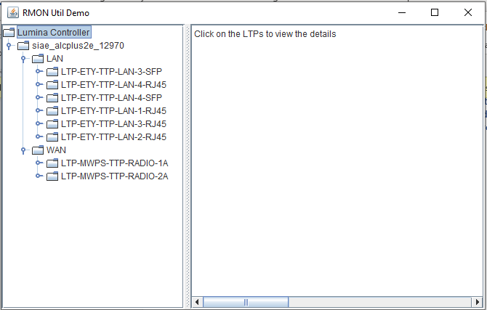

1. On expanding the WAN LTPs, we can able to view the following three functionality,

2.1) In the Internal connection option, we can able to see the internally connected LTPs. If an LTP is connected to more than one, that details will also be listed.

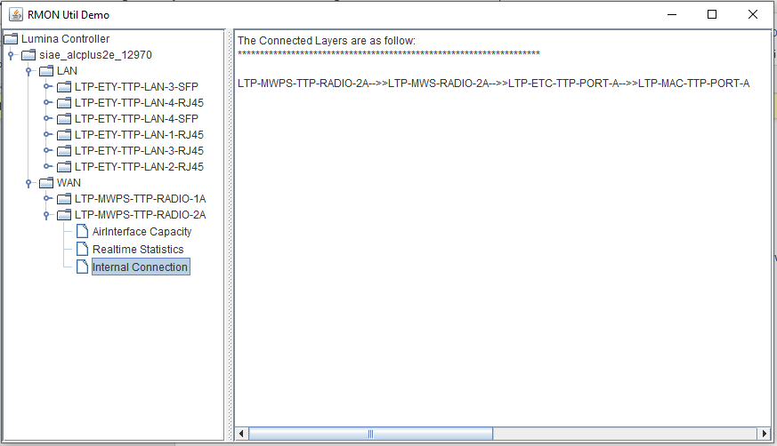

2.2) on clicking the air interface Capacity, we can able to see the results as below,

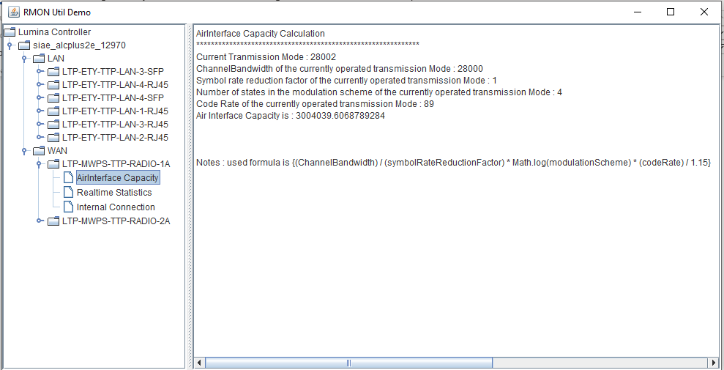

2.3) Option Realtime statistics shows the details as below, (as I m using SIAE device and its not having MAC layer implemented, not able to display the same

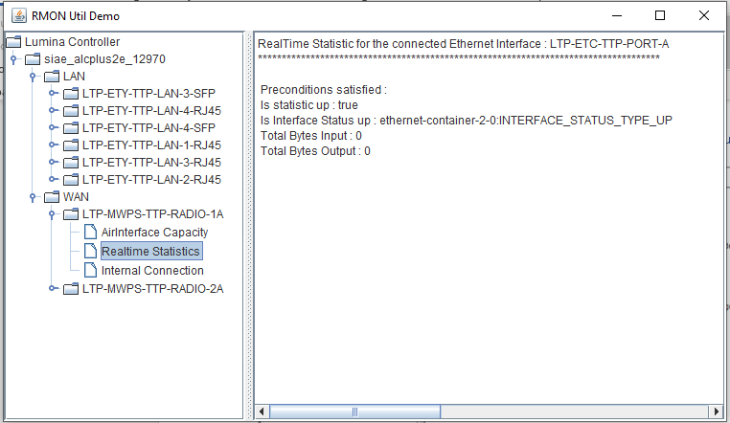

1. For LAN interfaces, apart from air interface capacity, other options will be available,

